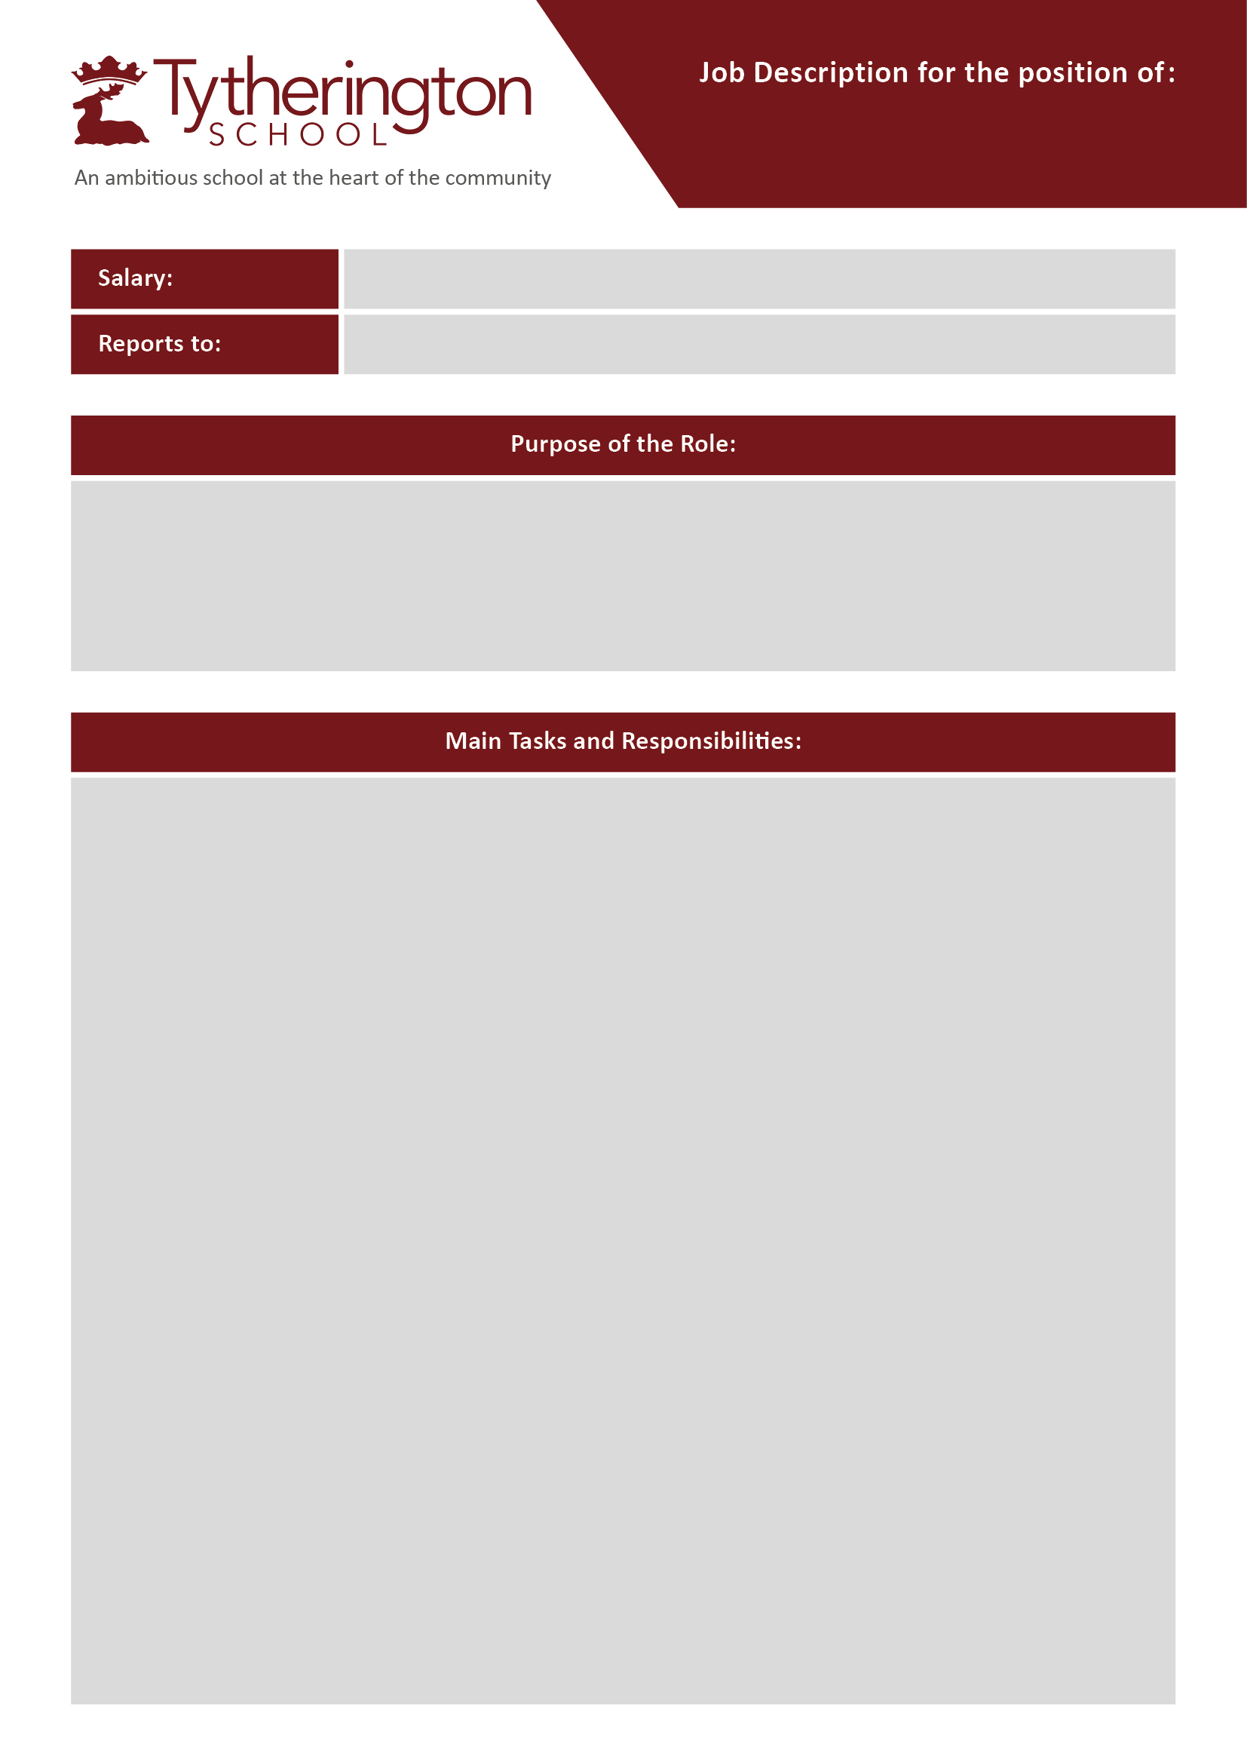
Sixth F
Sixth Form Pastoral Support Officer and Administrator
To support the work of the Sixth Form staff team and students in the provision of administrative and pastoral support, advice and guidance to allow the Head and Assistant Head of Sixth Form maximum time to devote to the management of the Sixth Form and to teaching.
The role requires high levels of professional judgement, emotional resilience and a strong commitment to safeguarding as everyone’s responsibility.

Key responsibilities:
Attendance. This includes:
- Proactively manage attendance and punctuality administration, including supervised study periods and collate reports of absence patterns.
- Liaise with parents and students about unauthorised absences and absence requests and other Sixth Form matters to facilitate upkeep of accurate daily attendance records.
Administration. This includes:
- Carrying out administrative tasks efficiently and effectively, to a professional standard to support the Head and Assistant Head of Sixth Form.
- Assisting with the recruitment and enrolment of new Sixth Form students, including leading the administration process for the recruitment and enrolment process using the relevant systems.
- Compilation of documentation necessary for the effective running of the Sixth Form and supporting Sixth Form events and activities.
- Maintaining records of post-18 destinations and mid-programme leavers.

Pastoral Support for Sixth Form students. This includes:
- Listening to students’ concerns and problems, treating those concerns in a confidential and supportive way and following them up assiduously. Entering information on CPOMS, where appropriate.
- Directing students to appropriate support services, or to other members of staff, where appropriate.
- Working with the Head and Assistant Head of Sixth Form to provide them with information and strategic support and advice in relation to students' issues.
- Overseeing the 6th form silent study periods when required.
- Maintaining a list of vulnerable students and ensuring that relevant student information is appropriately recorded on MIS student records.
- At all times, exercise professional judgement and experience as to how to proceed with student’s issues and concerns.

Support Staff Pay Scale: Grade 6 (40 weeks) Actual- £24,794 to £27,081p.a.

SLT Link for 6th Form/Head of Administration

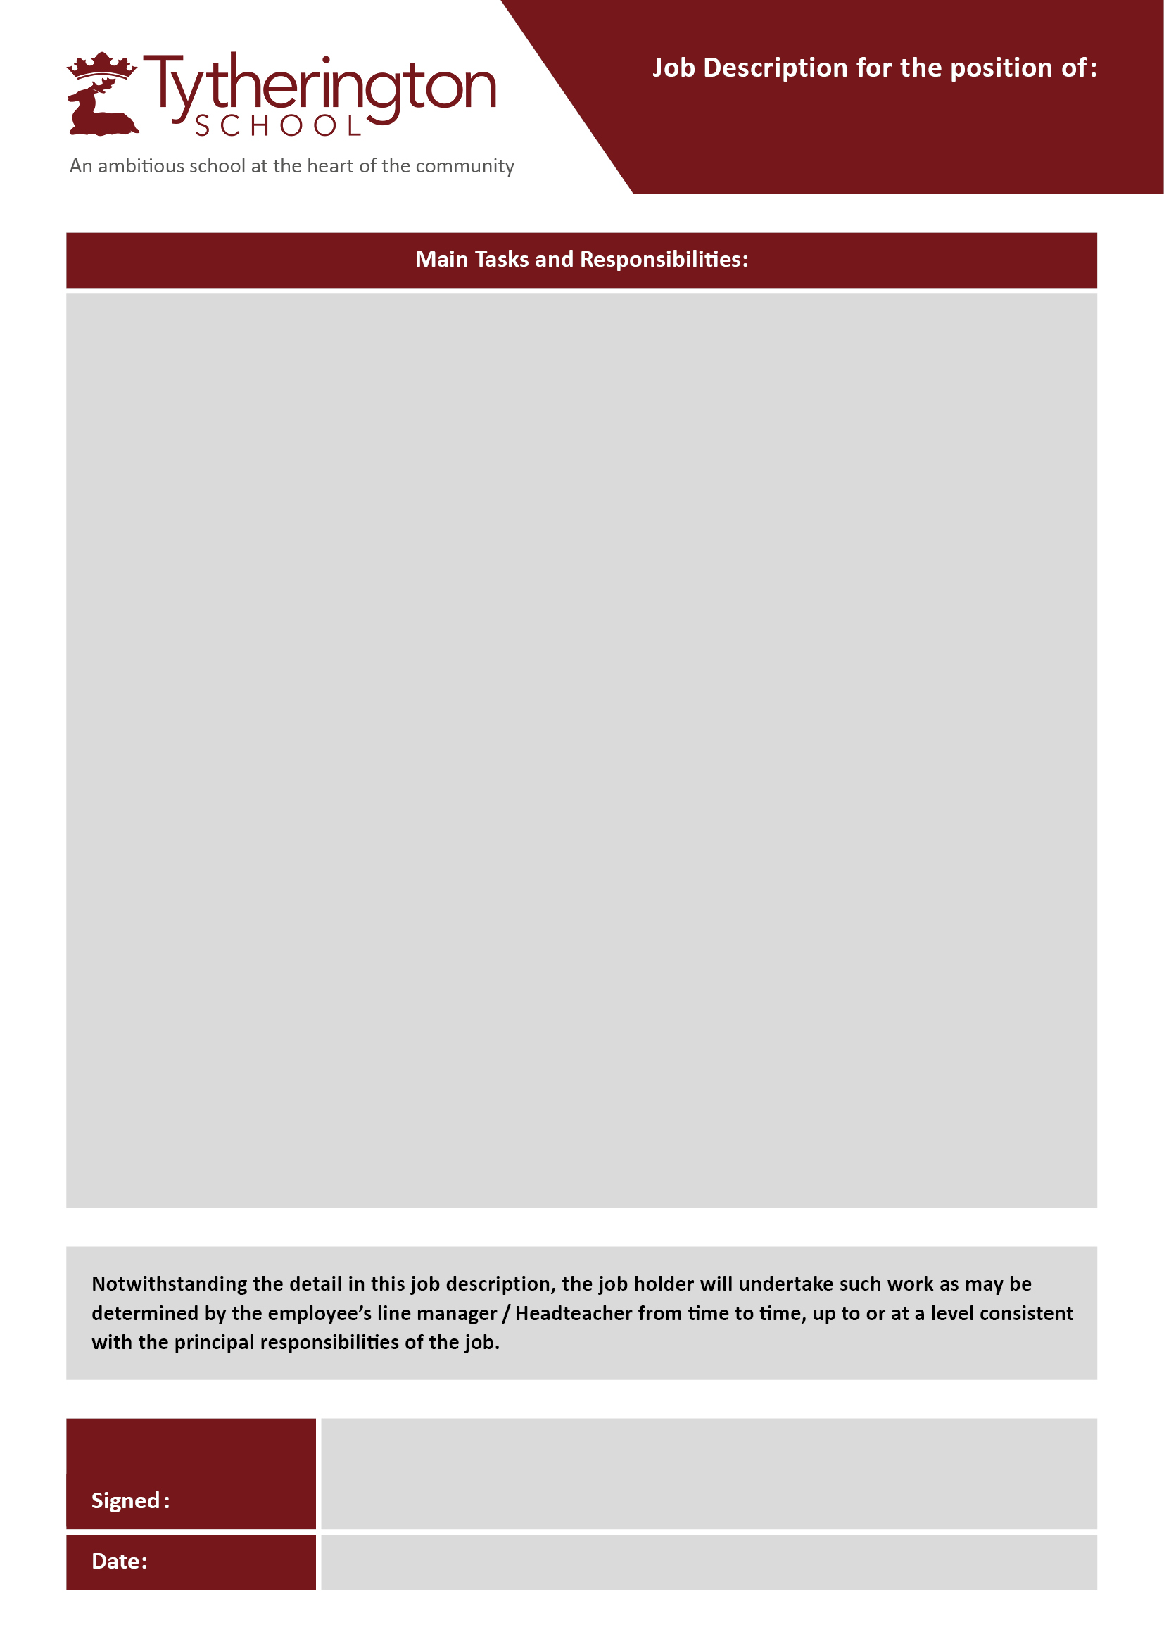
Communication. This includes:
- Liaising with teachers and other members of staff efficiently and professionally.
- Communicating professionally and effectively with parents and carers by telephone or written communication
- Identifying, contacting and working with external organisations, when appropriate, including supporting the arrangements of Sixth Form events.
- Arranging appointments for students with careers advisor
- Working collaboratively as a member of the Sixth Form Team, including making recommendations in respect of the introduction of new working practices and/ or resources to improve efficiency.
General duties

- To play a full part in the life of the school community by supporting its distinctive aims and values and to encourage students to follow this example.
- To promote and actively comply with the school’s policies, including the Health and Safety policy.
- To take part in regular training including termly cyber security awareness and safeguarding training.
- To attend school and relevant wider based training sessions as required or necessary.
- To fulfil the needs of the wider Pastoral and Inclusion Teams by working in partnership with the Deputy Headteacher (Strategic DSL), parents and relevant outside agencies.
- Maintain confidentiality regarding handling of sensitive data pertaining to students, staff, or school related matters to ensure the integrity of all data held in the school.
How to apply:
Please complete a Support Staff application on the school website outlining your skills and experience that make you a strong candidate for this post. Please see the Job Description and Person Specification for more details.
Further information about the selection process will be provided to shortlisted candidates.
The closing date is Monday 10th August 9am 2026. Interview date Friday 14th August 2026.
Interviews to be held w/c 18th May 2026.

Tytherington School is committed to safeguarding and promoting the welfare of children and expects staff working in all its schools to share this commitment. The successful applicant will be subject to an enhanced DBS check along with standard pre-employment safeguarding checks

Sixth Form Pastoral Support Officer and Adminstator

