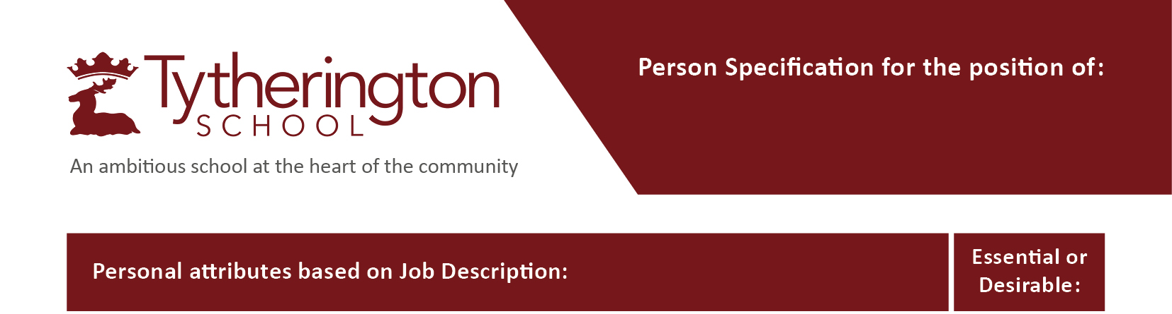
both
6th Form Pastoral Support Officer
and Administrator

Qualifications and Certification – assessed through application/interview/references if applicable

Good passes in English and Maths at GCSE or equivalent | Essential
First Aid at Work qualification | Desirable
Up to date training in Keeping Children Safe in Education | Desirable

Knowledge and Experience – assessed through application/interview/references if applicable

Knowledge of and competency in IT skills including the use of Microsoft Work, Excel, Teams | Essential
Excellent organisational and administrative skills | Essential
Experience of working with a school MIS system such as Bromcom | Desirable
Understanding of 6th form application process Applica Plus and UCAS application process | Desirable
.  Previous experience of working with children in a professional capacity | Desirable
The ability to build warm and effective professional relationships with staff, Students and parents | Essential

Skills and Attributes – assessed through application/interview/references

Effective communicator, able to respond sensitively to students and staff members | Essential
Good listener and ability to show empathy | Essential
Excellent communication— able to translate technical assessment outcomes into practical classroom strategies. | Essential
Ability to sensitively and positively manage difficult situations including conflict with staff, parents  and Students. | Essential
Ability to understand and support students with Special Educational Needs | Desirable
Ability to think and operate strategically, at a whole school level. | Essential

6th Form Pastoral Support Officer
and Administrator

Personal Qualities – assessed through application/interview/references

Empathy, professionalism, and confidentiality when working with students and families. | Essential
Ability to work individually and as part of a team | Essential

